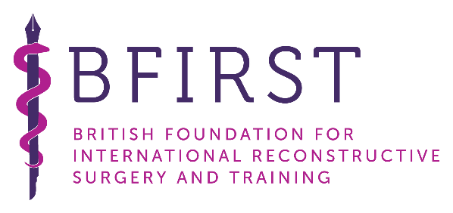

Overseas Fellowship

Application Form

**Who is eligible to apply for the BFIRST Fellowship?**

1. Fully Trained Plastic Surgeons: Senior Registrar or Consultant
2. Currently working within an established Plastic Surgery Unit in a developing country (please see fellowship webpage for list of priority countries)

**What should be included with your application?**

1. Complete this Application Form
2. Curriculum Vitae
3. Two Letters of Reference from Consultant Plastic Surgery colleagues supporting your application

Please see examples of previous CVs and application forms on the website.

**How is the application scored?**

The BFIRST Fellowship Subcommittee score the applications based on **5 domains:**

1. Reasons for applying for the fellowship - what would you like to achieve from this fellowship?

2. Impact of the fellowship in your home country - how will you be using this to benefit your own service, colleagues and country?

3. Clinical, academic and teaching experience - are you in a position to pass on your gained knowledge, and educate colleagues and trainees? How will you do this?

4. Leadership, charitable or collaborative experience - have you been involved in other charitable ventures, or established new projects to help disadvantaged populations previously?

5. Overall impression and references - enthusiasm, passion and possible opportunities to establish a long term working relationship with BFIRST

Please keep these points in mind when writing your application.

Please email a copy of your application form, CV and two references to [fellowship@bfirst.org.uk](mailto:fellowship@bfirst.org.uk)

| **Full Name** |  |  |
| --- | --- | --- |
| **Date of Birth** |  |  |
| **Gender** |  |  |
|  |  |  |
| **Surgical Position & Date Appointed** |  |  |
| **Hospital** |  |  |
| **City** |  |  |
| **Country** |  |  |
|  |  |  |
| **Home Address** |  |  |
|  |  |  |
| **Email** |  |  |
|  |  |  |
| **Do you have a contact in plastic surgery or a specific hospital you wish to visit in the UK?** |  |  |
|  |  |  |
| **Special areas of interest (eg: burns, hands, clefts, craniofacial, paediatric, head & neck, breast etc)**  **\*\*application for aesthetic surgery will not be accepted\*\*** |  |  |
|  |  |  |
| **When do you wish to start?** |  |  |
|  |  |  |
| **Have you previously been awarded a surgical fellowship? If so, please give details** |  |  |
| **Have you received financial support from BFIRST before? E.g. funding for other fellowships, loupes gifted, etc** |  |  |
|  |  |  |
| **Name of referee 1**  **Email** |  |  |
| **Name of referee 2**  **Email** |  |  |

| **Reason why you are applying for this fellowship (200 words maximum).**  Please include:   * Why do you wish to visit the UK? * Why do you wish to spend time in your chosen hospital? * What do you expect to gain from your visit? |
| --- |
|  |
| **If you are awarded the fellowship, please describe the impact it would have in your country (200 words maximum).**  Please include:   * How would it effect your surgical service? * Who, apart from yourself, would benefit if you are awarded the fellowship? * How will you share your UK experiences when you return to your country? |
|  |